**TORMACH PCNC 1100 MILLING MACHINE**

**QUICK START GUIDE**

Houston Community College, Stafford Campus

By James Vaughan

Thanks to Kris Asper and Arshad Hussain

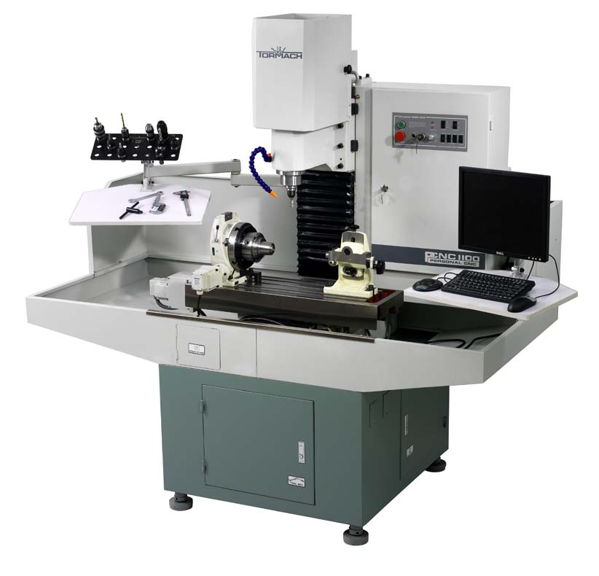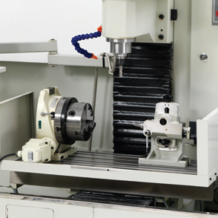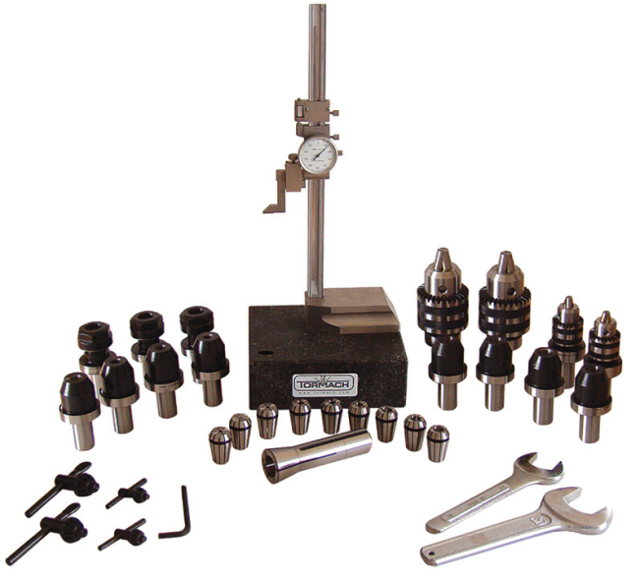

Last Revised August 9, 2011

**Contents:**

**1. Introduction p. 3**

**2. Machine Overview p. 4**

**3. Spindle p. 5**

**4. Cutters p. 8**

**5. Rotary Axis and Tailstock p. 9**

**6. Cutting Fluid p. 12**

**7. Maintenance p. 13**

**8. Startup and Shutdown p. 14**

**9. Jog Dial p. 15**

**10. Digitizer Probe p. 16**

**11. Software p. 17**

**12. Machine Shop Safety p. 18**

**1. Introduction**

This quick start guide is intended to help you get started with the Tormach PCNC 1100 milling machine. The instructions in this guide will help you quickly and easily set up the machine so that you may begin using it. With this guide, you will be able to set up the machine easily, without having to flip through bulky manuals.

While this guide contains much useful information, it is not a comprehensive resource. It does not contain instructions on using the SprutCAM or CAMWorks software packages, and it does not contain instructions on using the Tormach digitizer probe. For detailed information on those subjects, refer to their user manuals.

**2.** **Machine Overview**

**Name:** Tormach Personal CNC (PCNC) 1100 Series II

**Type:** Computer-controlled end mill milling machine

**Cutting ability:** The machine is able to cut most materials at their industry-standard speeds and feeds. For example, with 6061 aluminum, a ½ inch diameter 2-flute cutter can be run at 18 IPM (inches per minute), 3000 RPM, using a full ½ inch depth of cut, provided that the coolant spray is being applied to the cutting area. Harder materials such as iron and steel require much lower speeds and feeds.

**Precision:** The minimum distance this machine can move, called the “resolution of motion”, is 0.0001 inch. Considering other factors such as vibration and flexing of the machine and the cutter, this machine should be considered accurate to within 0.0013 inches per foot.

**Electronics:** The machines’ electronics and computer are, as of May 2011, properly set up and fully functional. One does not need to install any additional software or drivers or configure any of the electronics.

**Maximum Workpiece Weight:** 500 lbs.

**Maximum Spindle Nose to Table:** 17”

**Spindle Speed Range:** 250 to 5140 RPM

**Operating Temperature Range:** 45 to 100 ⁰F (7 to 38 ⁰C)

**Maximum Movement Speed:** 65 inches per minute (IPM)

**Rotary Axis:** The rotary axis is a Tormach accessory which is able to flip and rotate the workpiece.

**Rotary Axis Weight:** 69 lbs

**Rotary Axis Center Height:** 15.0 cm

**Rotary Axis (Vertical Position) Maximum Load Capacity:** 165 lbs

**Rotary Axis Minimum Rotation Angle:** 0.02 Degrees

**3. Spindle**

The spindle is the part of the machine that holds and turns the cutter. The cutter is held by what’s called a “tool holder”, which is held firmly in place by what’s called a “collet”, which is held firmly in place by a connecting rod called a “draw bar”.

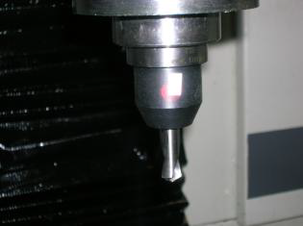

*The spindle*

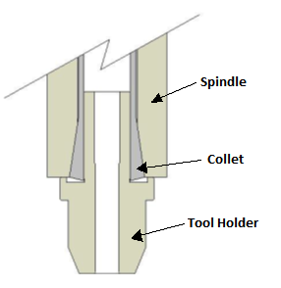

*Spindle, collet, and tool holder diagram.*

There are several different kinds of tool holders. There are ER 20 holders, set screw holders, drill chuck holders, and more.

**ER 20 holders:**

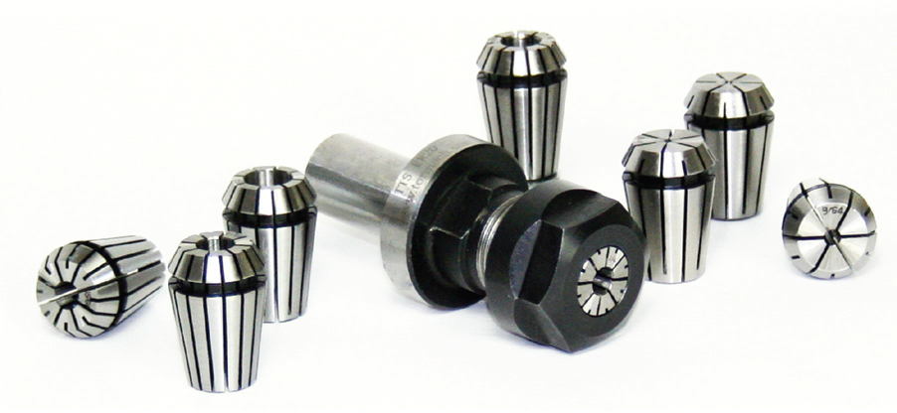

ER 20 holders (shown above) center the bit and hold it firmly, and are the best choice for precision milling jobs. Tighten the bit in place with a wrench.

**Set Screw Holders:**

Set screw holders use a locking screw and are intended to be used with bits that have a Weldon flat (a flat face) on their side. Never attempt to hold a tool that does not have a Weldon flat. Any tool mounted in a set screw holder will be held about 0.0003” off center due to the set screw and the required clearance. This will be significant in precision milling operations. The ER 20 collets mentioned above center the bit and are recommended for precision milling.

**Drill Chucks:**

Drill chucks are used in conjunction with Jacob’s taper adapters. Drill chucks are not designed to support side loads and should never be used to hold endmills or any other side cutting tools. The vibration, in conjunction with side loads from a milling operation, will generally shake the drill chuck off the mount. This has the potential for a very dangerous situation.

**Measuring the Tool Length:**

To measure a tool’s length, simply place it and its tool holder into the measuring fixture. With the height gauge and the granite measuring block, measure the length of the cutter and tool holder.

**Mounting a Tool Holder:**

To mount a tool holder and its cutter, follow these steps:

1. Open the spindle cover.
2. With the spindle lock fork, lock the spindle in place.
3. Turn the draw bar counter clockwise, loosening the collet.
4. If there is a tool holder already in place that you’d like to remove, pull it out when the collet is loose enough.
5. Place your tool holder in the collet and push it upwards as high as possible.
6. Turn the draw bar clockwise to tighten the collet. As it is tightened, the collet will pull the tool holder upwards. Tighten the draw bar until the tool holder is firmly pushing against the face of the spindle.
7. Disengage the spindle lock fork.
8. Close the spindle cover.

**4. Cutters**

The machine includes many different types of cutters, which range in size and type. You should only use genuine end mill cutters and not other cutters such as those from a cordless drill.

Cutters vary in size from tiny jeweler’s bits to large 1/2” diameter bits. Due to the small size and overall fragility of jeweler’s bits, you should not use them except in special circumstances that require extreme precision.

The bit’s “teeth” are called “flutes”. The number of the flutes can be important, because when bits have a greater number of flutes, they can drill through material at a faster rate.

Flat tips are called “square” tips. Rounded tips are called “ball” tips. Pointed tips are called “conical” tips.

**5. Rotary Axis and Tailstock**

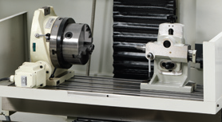

*Rotary axis (left) and tailstock (right)*

The machine includes a device called a “rotary axis” which holds the workpiece and rotates it along a horizontal or vertical axis. When the rotary axis is placed upright, it allows the PCNC 1100 to cut a part on the top, flip the part over, and then cut it on the bottom. This versatility makes cutting a part a bit faster and easier.

**Installing the Rotary Axis:**

In this campus’ two Tormach PCNC 1100 machines, the electronic components are already set up so that the machines will be able to connect to and use the rotary axis. One does not need to set up the internal electrical components or install driver software.

To install the rotary axis, follow these steps:

1. Place the rotary axis on the table, and place its locator key into the t-slot.
2. Firmly push the key against the t-slot in the direction shown by the arrow sign on the rotary axis.
3. With the clamps, firmly lock the rotary axis in place.
4. As of May 2011 one of the rotary axises has been oiled. However, there is a second rotary axis in the machine shop which has not been oiled. Check to see if the rotary axis you are using has been oiled. To check, look at the oil gauge on the side of the device. If it is about half full of oil, then the device has been oiled. IF THE DEVICE HAS NOT BEEN OILED, DO NOT USE IT UNTIL IT HAS BEEN OILED. USING A ROTARY AXIS WITHOUT OIL WILL DAMAGE THE DEVICE. If the device has not been oiled, follow these steps to oil it:
5. Obtain the proper lubricating oil. This device uses either SAE 80 hypoid gear oil, ISO 68 gear oil, AGMA 2 gear oil, or SAE 30 weight motor oil. Currently, there is a container of SAE 30 motor oil in the cabinet of one of the Tormach milling machines.
6. Place the rotary axis in the upright position.
7. Get an oil can or syringe which is able to inject oil.
8. Find the two oil inlet ports on the device. One is on the top of the jaw, and one is on the side of the device near the motor.
9. Push the ball bearing in and then inject the oil. Pump until there is some back pressure. Inject oil into both ports. Pump until the oil gauge shows oil up to the middle of the window. If you overfill the device, the oil reservoir will slowly leak until the oil drops to the correct level.
10. Connect the rotary axis to the machine with its cord. This cord connects to the rotary axis port on the right side of the PCNC 1100.
11. Generally, one should install the tailstock if one is planning to use the rotary axis.
12. Ensure that the tailstock is as level as possible.
13. Make sure the tailstock’s center is exactly 15.0 cm above the table.
14. Place the tailstock in the t-slot and push it against the t-slot in the direction shown by the arrow sign on the tailstock.
15. With the clamps, fasten the tailstock in place. The rotary axis and tailstock are now ready to be used.

**Mounting the Workpiece:**

To mount the workpiece, follow these steps:

1. If you will be using the tailstock, you must cut a hole for it. To cut such a hole, you may use what’s called a “center drill”, which is a special conical drill that is designed to cut an appropriate hole for the tailstock.
2. Place the workpiece in the rotary axis’ jaws.
3. Place the tailstock’s center into the hole. Lock the tailstock in place (make sure it is pressing against the t-slot in the direction shown by the arrow sign). Make sure the tailstock is firmly pressing against the workpiece.
4. Tighten the rotary axis’ jaws until they firmly grip the workpiece. The workpiece is now mounted.

**6. Cutting Fluid**

When cutting, the cutter can generate significant heat due to friction. Heat is undesirable because it may cause inaccuracy and may even melt the cutter. Cutting also generates chips (pieces of material) which can get in the way of the bit. To solve these problems, the machine has a cutting fluid pump which can spray cutting fluid onto the bit. This fluid, also called coolant or machining fluid, is used to cool the bit and wash away the chips. Generally, cutting fluid is a mix of oil and water. The oil helps prevent rust, and the water cools the bit. Cutting fluid also includes rust-inhibiting and anti-microbial compounds.

To use cutting fluid, place it in the machine’s cutting fluid tank. This tank can hold about 5 gallons of fluid, and if it has less than two gallons of fluid in it, it will not be able to draw out the fluid.

The cutting fluid that we are using must be diluted before it can be used. Mix one part fluid with two parts water. Water continuously evaporates from the tank (while the oil does not evaporate), so one must periodically add water to the tank. As of May 2011, the tank has approximately 1.25 gallons of cutting fluid in it, which needs to be diluted with about 2.5 gallons of water. There should be about 3.75 gallons of liquid in the tank when enough water has been added.

To use the fluid, simply flip the “coolant” switch on the control panel to “on”.

One can control the rate of the flow by using the control knob on the coolant hose.

In general, the cutting fluid does not cause rust, even if it is left on metal for long periods of time.

**7. Maintenance**

The main way to maintain the Tormach PCNC 1100 is to vacuum and clean it often to clear out the chips and debris. This will help protect the machine from damage and wear. Note that you should never use compressed air to clean the machine.

The machine also requires frequent lubrication. Without lubrication, its moving parts will wear out. WHENEVER THE MACHINE HAS BEEN SITTING IDLE FOR OVER 48 HOURS, OR WHENEVER THE MACHINE HAS BEEN OPERATING CONTINUOUSLY FOR OVER 4 HOURS, IT MUST BE LUBRICATED.

To lubricate the machine, use its built-in lubrication pump, which is located on the front of the machine. To operate this pump, pull out the handle all the way, and then let go. The handle is spring-driven and will retract back into the pump, lubricating the machine.

If the pump is out of oil, refill it with quality way oil. This could be Tonna 68 (Shell), Vactra No. 2 (Mobil), Way-lube 68 (Sunoco), WayLube 68 (Texaco), Febis 68 (Esso), or equivalent oil.

To protect from rust, you may mist the machine with light water repellant such as WD-40.

**8. Startup and Shutdown**

**Startup:**

To start up the Tormach PCNC 1100, follow these steps:

1. Make sure the “spindle lockout” key is in the “on” position – this allows the spindle to rotate.
2. Make sure the emergency stop button (the red button) is in the “out” position; if it is pressed in, twist it and it will come out.
3. Unless you want coolant to be running, make sure the “coolant” switch is in the “off” position.
4. Make sure the “computer” switch is in the “on” position.
5. Make sure the “manual/auto” switch is in the “auto” position – this allows the machine to be controlled by the computer.
6. Make sure the “forward/reverse” switch is set to “forward”.
7. Press the “start” button. The machine will turn on.
8. Allow the computer to start up. If it does not start up automatically, start it up manually by pressing the power button on the computer.
9. Once the computer has started up, open the Tormach PCNC 1100 program.
10. Once the program has started up, click the “Start” button on the screen once to make it turn solid green. The machine is now ready for use.

**Shutdown:**

To shut down the Tormach PCNC 1100, follow these steps:

1. Set the “coolant” switch to “off”.
2. From the computer’s Start menu, choose “Shut Down”.
3. Once the computer has safely shut down, press the emergency stop button (the red button) and the machine will turn off.

**9. The Jog Dial**

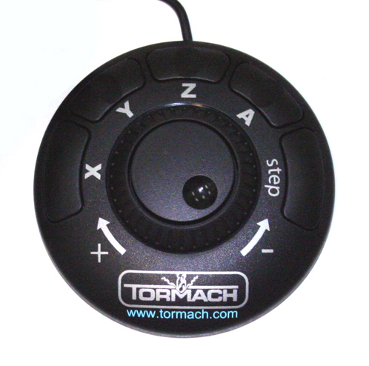

*The jog dial*

The Tormach PCNC 1100 includes a jog dial which allows the machine to be controlled manually. To control the machine with the dial, follow these steps:

1. In the Tormach PCNC 1100 program, click the “Jog ON/OFF” button to make the indicator by the button turn yellow.
2. Choose an axis to move the machine in. You may choose X, Y, Z, or A (for the rotary axis). Push the appropriate button (X, Y, Z, A) on the dial.
3. To move along that axis, turn the dial. The outer dial makes smooth motions, and the inner dial makes step motions.

**10. The Digitizer Probe**

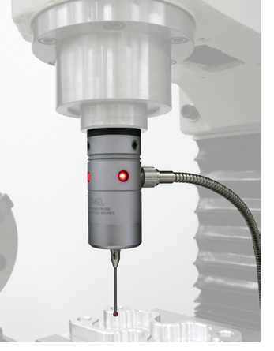

*The digitizer probe*

The Tormach PCNC 1100 includes an accessory called a “digitizer probe”. This accessory can measure the spindle’s location relative to the table or objects on the table. For more information about this device, refer to the Tormach PCNC 1100’s user manual.

**11. Software**



 

*Screenshots from SprutCAM*

The PCNC 1100 machine was bundled with a software package called SprutCAM 7. This software can be used to operate the machine. For instructions on how to use the SprutCAM software, refer to its user manual.

NOTE: SprutCAM 7 has been installed on one of the computers in the machine shop.

ALSO NOTE: In the near future, the software package known as CAMWorks will be installed, which will replace SprutCAM 7.

**12. Machine Shop Safety**

HOUSTON COMMUNITY COLLEGE SOUTHWEST, STAFFORD CAMPUS

MACHINE SHOP SAFETY REQUIREMENTS (revised 08/09/2011)

General Rules of Safety:

1. Always wear safety glasses, goggles, or safety shields designed for the type of work being done, when you or anyone near you is operating a machine.
2. Follow all proper rules and guidelines established in the machine’s user manual.
3. Always make sure your workplace is properly ventilated. If necessary, wear a respirator or mask.
4. When necessary, wear hearing protection.
5. Be sure you have sufficient light to see clearly when doing any job.
6. Be sure that all machines have effective and proper working guards.
7. Always see that work and cutting tools on any machine are clamped securely before starting.
8. Do not attempt to oil, clean, adjust or repair any machine while it is running.
9. Do not try to stop the machine with your hands or body.
10. Never use compressed air to clean your clothes or any part of your body, as it can cause a medical emergency.
11. Don’t rush speeds and feeds. You’ll end up damaging your part, the tools, and maybe the machine itself.
12. Do not lean against the machines.
13. Do not leave a machine while it is running. Someone else may not notice it is still running, and be injured.
14. Concentrate on the work and the machine at all times, it only takes a moment for an accident to occur. Do not talk unnecessarily while operating a machine.
15. If you are unsure about the safe operation of a tool or any aspect of a job, ask for help from your professor.
16. Never work after you have been drinking or when you are impaired, fatigued, or in a hurry.
17. When working with another person, only one should operate the machine or switches at a time.
18. No horseplay or roughhousing.
19. Never work alone.
20. Get help when handling long or heavy pieces of material.
21. Get first aid immediately for ANY injury. Do not attempt to remove foreign objects from your eyes or body. If chemicals get in your eye(s), rinse eye(s) with running water for 15 minutes in an open flow of water and get medical attention. Report all accidents and injuries to your instructor immediately. In an emergency, call 911. The shop is room S125 in the Scarcella building in the Stafford campus.

Rules Concerning Clothes and Safety Equipment:

1. Wear clothes suited for the job.
2. Do not wear loose-fitting clothes or ties.
3. Wearing of shorts or cutoff pants is not allowed in the shop. Hot chips can cause cuts and burns.
4. Open toe shoes are not allowed in the shop. Shoes must cover the entire foot to be acceptable.
5. Long hair must be kept up at all times. It is easy for long hair to get caught in moving machinery.
6. Do not wear rings, watches, bracelets or other jewelry that could get caught in moving machinery.
7. Always remove gloves before turning on or operating any machine.

Rules Concerning Housekeeping:

1. Floor should be kept clear at all times to avoid tripping or other accidents.
2. Keep floors free of oil, grease or any other liquid. Clean up spilled liquids immediately; they are slipping hazards.
3. Keep the floor clear of metal chips and waste pieces. Put them in the container provided for scrap.
4. Put tools away when not in use. Turn off all machines before leaving the shop.
5. Vacuum or sweep debris from machine before using.
6. Never use compressed air for cleaning the machines.